Base Class and Derived Class
- once a derived class is inherited from a base class ,it will have the same member as the the base class from Public and Protected section
当导类继承基类时，导类会有所有基类Public和Protect范围中成员的访问权限(内存地址)
//因为编译器对待非原始数据类型的值时总是传入地址

- 导类不能继承基类中Private范围中成员的内存地址
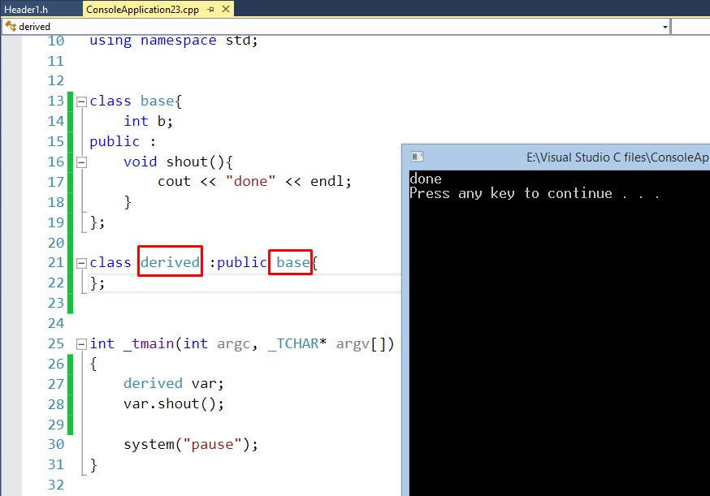
class derived : public base

protected修饰符
- protected is a keyword act as private outside of the class and acts as public within the class AND the class hierarchy and the inheriting classes
- 被protect修饰的成员 对类外部来说是 私有，对类内部和它的基类和导类来说是 公有
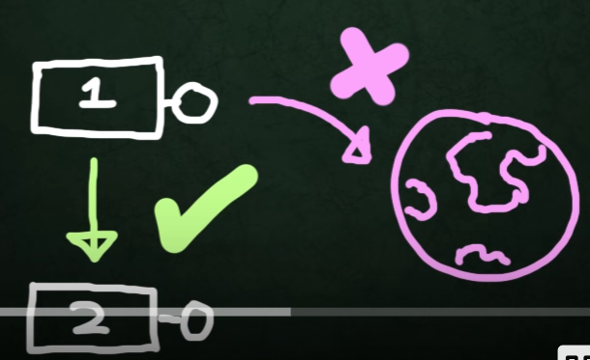
证:
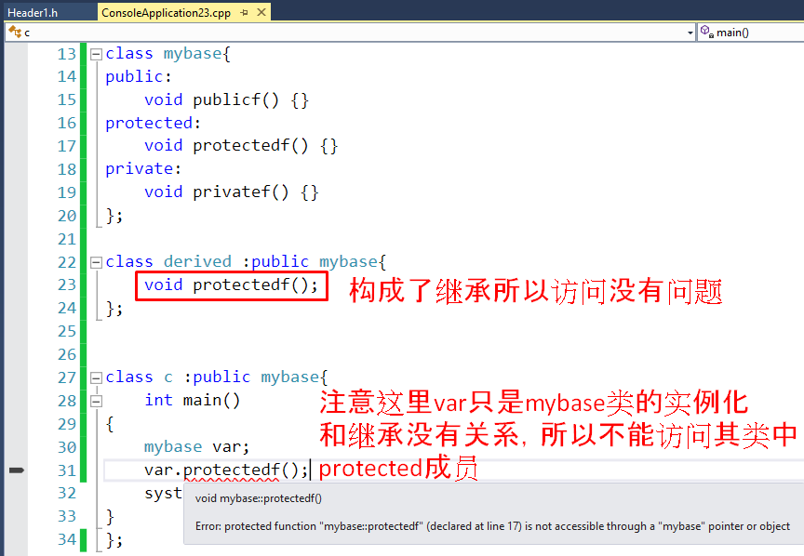
- 注意实例化和继承的区别
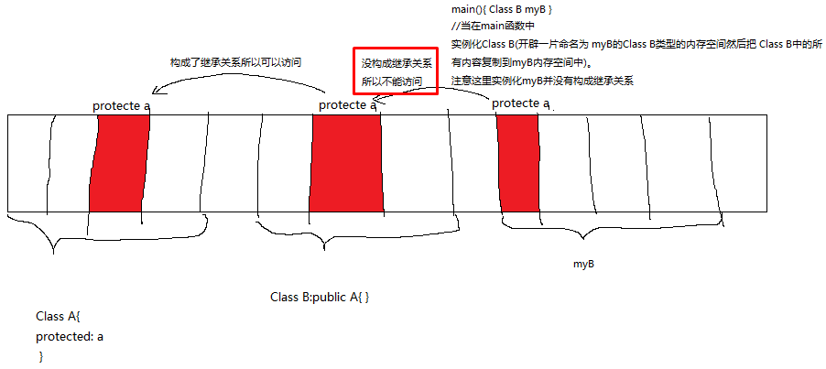

- 被protected修饰的所有成员可以被多重继承(包括构造函数和拆解函数)
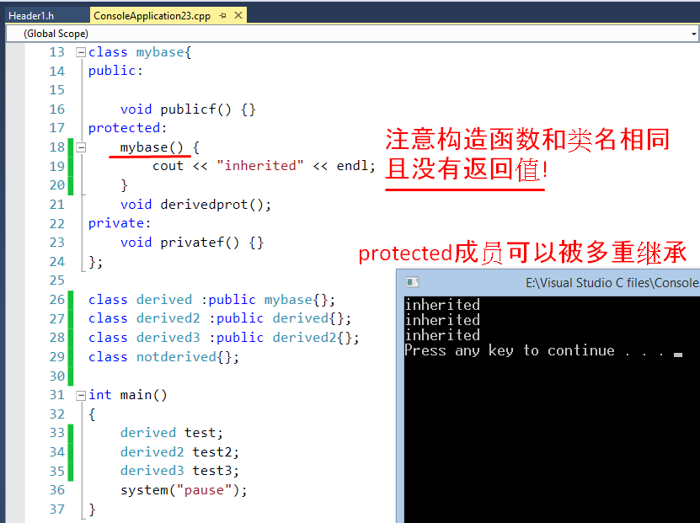
//注意构造函数和类名相同且没有返回值

- class derived: public mybase{}; 写法和 class derived : protected mybase{}; 结果是一样的
因为导类自动继承protected中的成员，而public中的成员又是类的外部可以访问到的，
所以在写继承声明的时候，不管用public还是protected修饰，导类都可以访问到基类中public和protected成员
